Project Title: Intelligent Vehicle Damage

Assessment and Cost Estimator Project Design Phase-I - Solution Fit Template Team ID: PNT2022TMID00886

for Insurance Companies

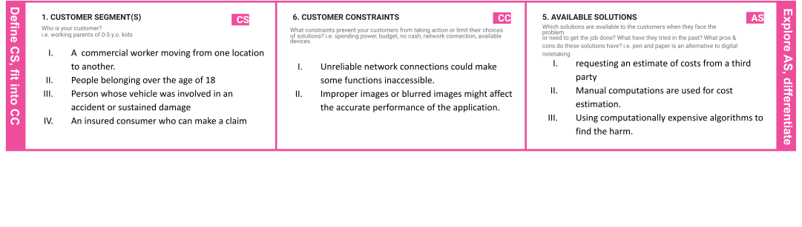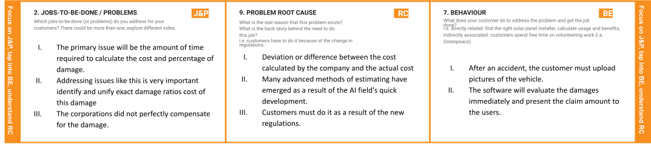

|  |  |  |  |  |
| --- | --- | --- | --- | --- |
|  | **3. TRIGGERS TR**  What triggers customers to act? i.e. seeing their neighbour installing solar panels, reading about a more efﬁcient solution in the news.   1. The development of forecasting and estimation technology. 2. Society and coworkers are requesting a swift insurance claim 3. Independent consumer wanting to avoid false traps. | **10. YOUR SOLUTION SL**  If you are working on an existing business, write down your current solution ﬁrst, ﬁll in the canvas, and check how much it ﬁts reality.  If you are working on a new business proposition, then keep it blank until you ﬁll in the canvas and come up with a solution that ﬁts within customer limitations, solves a problem and matches customer behaviour.   1. Accurately calculate the damage percentage. 2. Forecast the region of damage as it relates to the car. 3. Employ rapid processing algorithms for functionality. | 1. **CHANNELS of BEHAVIOUR CH**    1. **ONLINE**   What kind of actions do customers take online? Extract online channels from #7   * 1. **OFFLINE**   What kind of actions do customers take ofﬂine? Extract ofﬂine channels from #7 and use them for customer development.   * 1. ONLINE      1. Using an input image, you can browse a website to estimate the damage.      2. Access to the artificial intelligence-based damage assessment technique. |  |

|  |  |  |  |  |
| --- | --- | --- | --- | --- |
|  | **4. EMOTIONS: BEFORE / AFTER EM**  How do customers feel when they face a problem or a job and afterwards?  i.e. lost, insecure > conﬁdent, in control - use it in your communication strategy & design.  Before:  Delay in insurance claim.  failure to adequately compensate for vehicle damage.  After:  Clients felt independent,  they received their insurance claims instantly,  were able to evaluate a combined insurance  claim for the damage inflicted to their vehicle. | 1. A technique that is user-friendly, engaging, and easy for the user to access The current solution operates inefficiently. 2. Removing human estimation from the process | * 1. OFFLINE      1. Contact the relevant insurance company or bank to continue the insurance payment procedure. |  |